**Chapter 1: Lecture Notes**

1. **Data Communication**

The word data refers to information presented in a form which is agreed upon by the parties creating and using the data.

Data communication is the exchange of data between two devices via some form of transmission medium such as a wire cable.

For data communications to occur, the communicating devices must be part of a communication system made up of a combination of hardware (physical equipment) and software (programs).

Effectiveness of data communication depends on four fundamental characteristics:-

1. Delivery

* System must deliver data to the correct destination.
* Data must be received by the intended device and only by that device.

1. Accuracy

* System must deliver the data accurately.
* If data is altered during transmission, it should be corrected or resent.

1. Timeliness

* System must deliver data in a timely manner.
* Data delivered late are useless.

1. Jitter

* Refers to the variation in the packet arrival time.

Example:

The uneven delay in the delivery of audio or video packets. For example, let us assume that video packets are sent every 30ms. If some of the packets arrive with 30ms delay and others with 40ms delay, an uneven quality in the video is the result.

* 1. **Components of Data Communication**

A data communications system has five components.

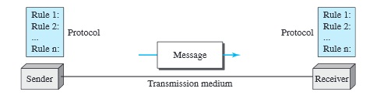

Figure 1: Five components of a data communication system

1. Message

The message is the data to be communicated. Example: text, numbers, pictures, audio, and video.

1. Sender.

The sender is the device that sends the message. Example: computer, mobile phone

1. Receiver.

The receiver is the device that receives the message. Example: computer, mobile phone

1. Transmission medium.

The transmission medium is the physical path by which a message travels from sender to receiver. Examples: twisted-pair wire, coaxial cable, fiber-optic cable.

1. Protocol.

A protocol is a set of rules that govern data communications. It represents an agreement between the communicating devices. Without a protocol, two devices may be connected but not communicating.

Example: A person speaking French cannot be understood by a person who speaks only Japanese. As a solution both can agree to speak in English. (It can be said that talking in English is the protocol here).

* 1. **Data representation**

Data can be represented in a variety of forms.

1. Texts

* Represented as a bit pattern, a sequence of bits (0s or 1s)
* Different sets of bit patterns represent different texts.
* ASCII code used to represent is commonly used.

1. Numbers

* Represented as a bit pattern
* However code such as ASCII is not used, the number is directly converted to its binary equivalent

1. Images

* Represented as bit patterns
* Simplest representation resembles a matrix consisting of 0s and 1s

1. Audio files

* Has continuous values unlike text or numbers which has discrete values(0 or 1)

1. Video files

* Can be either continuous or discrete
  1. **Data Flow**

Communication between two devices can be simplex, half-duplex or full-duplex.

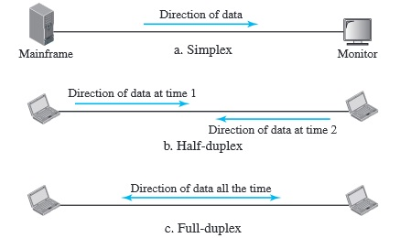

Figure 2: Data flow

1. Simplex mode

* Communication is unidirectional, as on a one-way street
* Only one of the two devices on a link can transmit, the other can only receive (Figure 2a)
* Example of simplex devices: Keyboard, mouse
* Simplex mode can use the entire capacity of the channel to send data in one direction.

1. Half-Duplex mode

* Both devices can send and receive, but not at the same time.
* When one device is sending, the other can only receive, and vice versa
* It is like a one-lane road with traffic allowed in both directions but when cars are traveling in one direction, cars going the other way must wait.
* The entire capacity of a channel is taken over by whichever of the two devices is transmitting at the time
* Example: Walkie-Talkies

1. Full-Duplex mode

* Both devices can transmit and receive simultaneously
* It is like a two-way street with traffic flowing in both directions at the same time.
* Signals going in one direction share the capacity of the link with signals going in the other direction.
* Sharing of the capacity can occur in two ways:-

1. link can contain two physically separate transmission paths, one for sending and the other for receiving
2. the capacity of the channel is divided between signals traveling in both directions

* Example: Mobile phones

1. **Network**

A network is the interconnection of a set of devices capable of communication. Devices are connected using either a wired or a wireless transmission media.

* 1. **Network Criteria**

Any network must meet certain criteria. Some of the important network criteria are Performance, Reliability and Security.

1. Performance
2. Measurement of performance

* Performancecan be measured in many ways, including transit time and response time.
* Transit time is the amount of time required for a message to travel from one device to another.
* Response time is the elapsed time between an inquiry and a response.

1. The performance of a network depends on a number of factors, including the number of users, the type of transmission medium, the capabilities of the connected hardware, and the efficiency of the software.
2. Evaluation of performance

It is evaluated by two networking metrics: throughput and delay.

NOTE:

Bandwidth: Maximum transmission capacity of a transmission media.

Throughput: Amount of data transmitted by a transmission media at an instance of time.

Example: Consider a highway, bandwidth tell us what the maximum number of cars that can come down the highway over a period of time. However, perhaps due to road blocks or some other obstacle in between, we see fewer cars come down the highway, over a period of time, this is throughput.

1. Reliability

Measured by the frequency of failure, the time it takes a link to recover from a failure, and the network’s robustness in a catastrophe.

1. Security

Includes protecting data from unauthorized access, protecting data from damage and development, and implementing policies and procedures for recovery from breaches and data losses.

* 1. **Physical Structures**
     1. **Type of connection**

A network is two or more devices connected through links. A link is a communications pathway that transfers data from one device to another.

There are two possible types of connections: point-to-point and multipoint.

1. Point to point

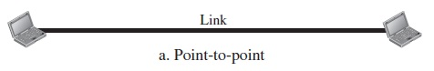

* Provides a dedicated link between two devices.
* Entire capacity of the link is reserved for transmission between those two devices

1. Multipoint

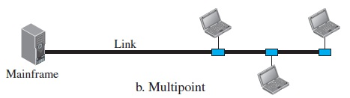

* More than two specificdevices share a single link
  + 1. **Physical Topology**

The term physical topology refers to the way in which a network is laid out physically. Two or more devices connect to a link; two or more links form a topology. There are four basic topologies possible: mesh, star, bus, and ring.

* 1. Mesh

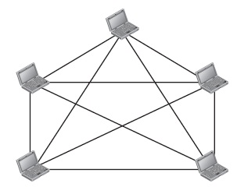

Figure 3: Mesh topology

* Every device has a dedicated point-to-point link to every other device
* If there are n devices. For simplex mode n(n-1) connections are needed.
* For duplex mode n(n-1)/2 connections are needed.

Advantages:

* The use of dedicated links guarantees that each connection can carry its own data load, thus eliminating the traffic problems
* It is robust. If one link becomes unusable, it does not incapacitate the entire system.
* It is secure. A dedicated line allows only the intended recipient to see the message
* Fault identification and fault isolation is easy.

Disadvantages:

* Large amount of cabling is required as every device is connected to every other device
* Installation and reconnection is difficult.

Example of Mesh topology: Connection of telephone regional offices in which each regional office needs to be connected to every other regional office.

* 1. Star

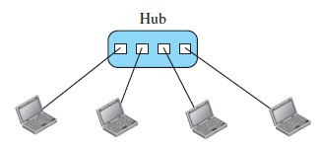

Figure 4: Star topology

* Each device has a dedicated point-to-point link only to a central controller, usually called a hub.
* Unlike a mesh topology, a star topology does not allow direct traffic between devices. The controller acts as an exchange
* If one device wants to send data to another, it sends the data to the controller, which then transmits the data to the other connected device

Advantages:

* Less cabling is required
* Robust, if one link fails the others are not affected
* Fault identification and fault isolation is easy

Disadvantages:

* There is a dependency of the whole topology on one single point, the hub. If the hub goes down, the whole system is dead

Example of Star topology: The star topology is used in local-area networks (LANs).

* 1. Bus

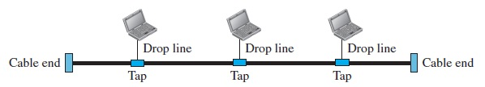

Figure 5: Bus topology

The preceding examples all describe point-to-point connections. A bus topology, on the other hand, is multipoint. One long cable acts as a backbone to link all the devices in anetwork.

* Nodes are connected to the bus cable by drop lines and taps
* A tap is a connector that splices into the main cable to make a connection
* As signal travels along the backbone, it becomes weaker and weaker, as a result there is a limit on the number of devices that can connect to the backbone of a bus.

Advantages:

* Ease of installation
* Less cabling required

Disadvantages:

* Difficult reconnection and fault isolation
* Fault or break in the backbone stops all transmission
  1. Ring

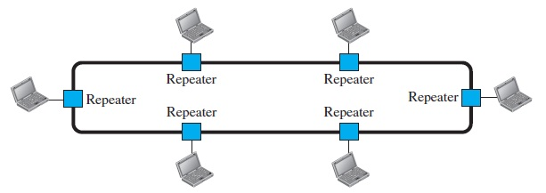

Figure 6: Ring topology

* Each device has a dedicated point-to-point connection with only the two devices on either side of it.
* A signal is passed along the ring in one direction, from device to device, until it reaches its destination
* Each device in the ring incorporates a repeater. When a device receives a signal intended for another device, its repeater regenerates the bits and passes them along

Advantages:

* Easy to install and reconfigure
* Fault isolation is simple

Disadvantage:

* Unidirectional traffic can be a disadvantage. a break in the ring can disable the entire network. This can be resolved by using a dual ring which allows traffic in both directions
  + 1. **Network Types**

LAN, MAN, WAN. Refer Data Communications and networking by Forouzan.

* + 1. **Internet**

It is very rare to see a LAN, a MAN, or a WAN in isolation; they are connected to one another. When two or more networks are connected, they become an internetwork, or internet.

* + 1. **Protocols and Standards**

1. Protocols

* Set of rules that govern data communication
* A protocol defines what is communicated, how it is communicated, and when it is communicated
* The key elements of a protocol are syntax, semantics, and timing.

Syntax

* Refers to the structure or format of the data, meaning the order in which they are presented
* Example, a simple protocol might expect the first 8 bits of data to be the address of the sender, the second 8 bits to be the address of the receiver, and the rest of the stream to be the message itself.

Semantics

* Semantics refers to the meaning of each section of bits. How is a particular pattern to be interpreted, and what action is to be taken based on that interpretation
* Example, does a sequence of bits represent the source address or the destination address.

Timing

* Timing refers to two characteristics: when data should be sent and how fast they can be sent.

1. Standards

* Refers to agreed upon set of rules.
* It is essential in creating and maintaining an open and competitive market for equipment manufacturers and in guaranteeing interoperability of data and communications technology and processes

1. **Network Models**

A network is a combination of hardware and software that sends data from one location to another. The hardware consists of the physical equipment that carries signals from one point of the network to another. The software consists of instruction sets that make possible the services that we expect from a network.

**Layered tasks in a postal mail service**

* The process of sending a letter involves a layer of different tasks.
* The layers help in effective execution of the tasks. Without the layered approach, it would be difficult to efficiently execute the different tasks.

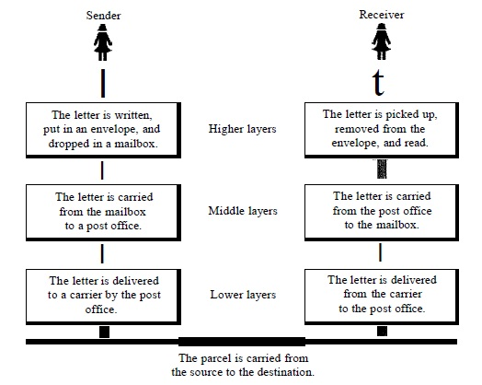

Figure 7: Tasks involved in sending a letter

As seen in the figure there is a sender, a receiver, and a carrier that transports the letter. There is a hierarchy of tasks.

**Sender Side**

Higher Layer: The sender writes the letter, inserts the letter in an envelope, writes the sender and receiver addresses, and drops the letter in a mailbox.

Middle Layer: The letter is picked up by a letter carrier and delivered to the post office.

Lower layer: The letter is sorted at the post office and a carrier transports the letter.

On the way to the recipient’s post office, the letter may go through many other post offices. In addition it may be transported by truck, train or a plane.

**Receiver Side**

Lower layer: The carrier transports the letter to the post office

Middle layer: The letter is sorted and delivered to the recipient's mailbox

Higher layer: The receiver picks up the letter, opens the envelope, and reads it.

It can be observed from the figure that at the sender side there is a downward flow in the sequence of tasks that is carried: the sender writes the letter, puts in an envelope, posts the letter and finally the letter is carried by a carrier. At the receiver side, there is an upward flow.

Each task, both at the sender side and at the receiver side is carried out in a sequence (one after the other). It can also be observed from the figure that at the sender’s side, each layer uses the services of the layer immediately below it. Example, the carrier (lower layer) provides service to the post office (middle layer), whereas the post office provides service to people in sending their letters.

Additionally, the post office adds some information of its own in every letter that is posted (a post office usually makes a rubber stamp mark on the envelope indicating the date and other information). This information is used by the destination post office in sorting the letters. It can thus be said that during communication of the letters, a layer at the sender side provides service to the corresponding layer at the receiver side (This is referred to as peer to peer process in data communication).

**The OSI Model**

* Referred to as the ISO-OSI model or the OSI model
* The purpose of the OSI model is to facilitate communication between different systems without requiring changes to the logic of the underlying hardware and software.
* It consists of seven layers.

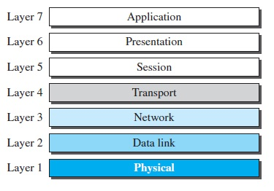

Figure 8: Seven layers of the OSI model

* Each layer provides services to the layer immediately above it. Layer 2 provides services to layer 3, layer 3 provides services to layer 4 and so on.

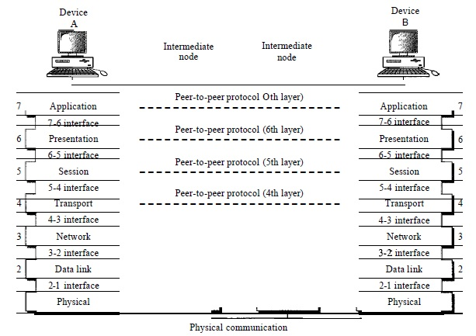

Figure 9: Communication between devices employing the OSI model and the interaction between different layers

* Between machines, layer *x* on one machine communicates with layer *x* on another machine (Data Link layer of the sender machine provides service to data link layer of the receiver machine)
* The processes on each machine that communicate at a given layer are called peer-to-peer processes
* At the sender side, data must move down through the layers (Application to Physical).
* At the receiver side, data must move up through the layer (Physical to Application).
* Each layer of the sender adds its own information to the message it receives from the layer just above it and passes the whole package to the layer just below it.
* At the Physical layer, the entire package is converted to a form that can be transmitted to the receiving device via a transmission medium.
* At the receiver, the message is unwrapped layer by layer, with each layer receiving and removing the data meant for it. For example, layer 2 removes the data meant for it, then passes the rest to layer 3. Layer 3 then removes the data meant for it and passes the rest to layer 4, and so on.
* The passing of the data down through the layers of the sender and back up through the layers of the receiver is made possible by an interface between each pair of adjacent layers.
* Each interface defines the information and services a layer must provide for the layer above it.
* The seven layers can be thought of as belonging to three subgroups:-
  + Network support layers (Physical, Data Link and Network layers): Deals with the physical aspects of moving data from one device to another (such as electrical specifications, physical connections, physical addressing, and transport timing and reliability)
  + User support layers (Session, Presentation and Application layers): They allow interoperability among unrelated software systems.
  + The transport layer, links the two subgroups and ensures that what the lower layers have transmitted is in a form that the upper layers can use.
* The upper OSI layers are almost always implemented in software; lower layers are a combination of hardware and software, except for the physical layer, which is mostly hardware.

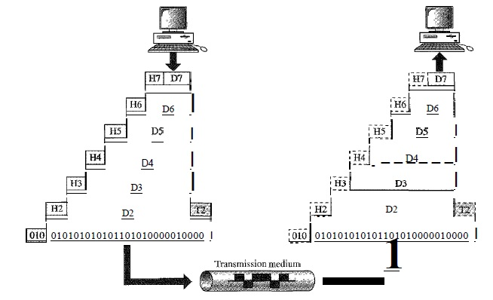

Figure 10: Data exchange using the OSI model

* The above figure gives an overall view of data communication using the OSI model. D7 means the data unit at layer 7, D6 means the data unit at layer 6, and so on.
* The communication starts at layer 7 (the application layer) of the sender side, then moves from layer to layer in descending, sequential order.
* At each layer, a header, or possibly a trailer, can be added to the data unit. Commonly, the trailer is added only at layer 2.
* When the data passes through the physical layer (layer 1), it is changed into an electromagnetic signal and transported along a physical link.
* Upon reaching its destination, the signal passes into layer 1 and is transformed back into digital form.
* The data units then move back up through the OSI layers. As each block of data reaches the next higher layer, the headers and trailers attached to it at the corresponding sending layer are removed, and actions appropriate to that layer are taken.
* By the time it reaches layer 7, the message is again in a form appropriate to the application and is made available to the recipient.

NOTE:

Figure reveals another aspect of data communications in the OSI model: encapsulation. A packet (header and data) at level 7 is encapsulated in a packet at level 6. The whole packet at level 6 is encapsulated in a packet at level 5, and so on.

**Layers in the OSI model**

1. Physical Layer

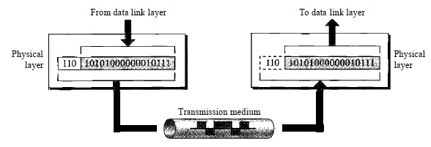

The physical layer is responsible for the following:-

* Physical characteristics of interfaces and medium: The physical layer defines the characteristics of the interface between the devices and the transmission medium. It also defines the type of transmission medium.
* Representation of bits: The physical layer data consists of a stream of bits with no interpretation. To be transmitted, bits must be encoded into signals. The physical layer defines the type of encoding (how 0s and 1s are changed to signals).
* Data rate: The transmission rate-the number of bits sent each second-is also defined by the physical layer.
* Line configuration: The physical layer is concerned with the connection of devices to a communication media, whether it is a point-to-point or a multipoint connection.
* Topology: Mesh, Star, Bus, Ring
* Transmission mode: The physical layer also defines the direction of transmission between two devices: simplex, half-duplex, or full-duplex.

1. Data Link Layer

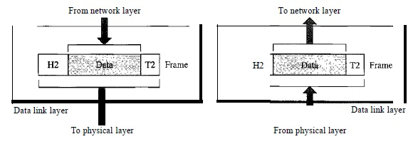

The data link layer is responsible for the following:-

* Framing: The data link layer divides the stream of bits received from the network layer into manageable data units called frames.
* Physical addressing: The data link layer adds a header to define the physical address of the sender and receiver.
* Flow control: If the rate at which the data absorbed by the receiver is less than the rate at which data is produced in the sender, the data link layer imposes a flow control mechanism to avoid overwhelming the receiver
* Error control: The data link layer adds reliability to the physical layer by adding mechanisms to detect and retransmit damaged or lost frames. It also uses a mechanism to recognize duplicate frames. Error control is normally achieved through a trailer added to the end of the frame.

**TCP/IP model**

|  |
| --- |
| Application Layer |
| Transport Layer |
| Network Layer |
| Data Link Layer |
| Physical Layer |

* TCP stands for Transmission Control Protocol. IP stands for Internetworking Protocol.
* The TCP/IP protocol suite was developed prior to the OSI model. Therefore, the layers in the TCP/IP protocol suite do not exactly match those in the OSI model.
* TCP/IP model has five layers as seen in the figure above.

1. Physical and Data Link Layer

At the physical and data link layers, TCP/IP does not define any specific protocol. It supports all the standard and proprietary protocols. A network in a TCP/IP internetwork can be a local-area network or a wide-area network.

1. Network Layer

* At the network layer, TCP/IP supports the Internet Protocol.
* IP in turn, uses four supporting protocols: ARP, RARP, ICMP, and IGMP
* Internetworking Protocol
  + The Internetworking Protocol (IP) is the transmission mechanism used by the TCP/IP protocols.
  + It is an unreliable and connectionless protocol, a best-effort delivery service. The term best effort means that IP provides no error checking or tracking.
  + IP transports data in packets called datagrams.

1. Transport Layer

There are two protocols in the transport layer of the TCP/IP model:-Transmission Control Protocol (TCP) and User Datagram Protocol (UDP).

1. Application Layer

The application layer in TCP/IP is equivalent to the session, presentation and application layers combined in the OSI model.

NOTE:

For data communications the TCP/IP model is used. The OSI model was developed when TCP/IP was already in use. The OSI model was never used although it has a better decomposition of layers and their functionality.

**Addressing**

There are four levels of addressing:-

Physical address: It is imprinted on the Network Interface Card (NIC) by the manufacturer. Generally is 48 bits.

Logical address:

* Physical addresses are not adequate in the internet where different networks can have different address formats. In order to identify each device uniquely, regardless of the underlying physical network, the logical address was defined.
* A logical address in the internet is currently a 32-bit address.

Port address:

* In computers, data needs to be communicated between processes running on them.
* There are a number of processes running simultaneously.
* In order to uniquely identify the processes, a port address is used.

Specific address

Some applications have user-friendly addresses that are designed for that specific address. Examples include the e-mail address (Example, admissions@smit.com) or the URL (Example, www.smu.edu.in).